

oneM2M
Technical Report
Document Number | TR-0021-V-0.5.0
Document Name: | Study of the action triggering in M2M
Date: | 2016-July-27
Abstract: | The document is a study of the action triggering in M2M. Based on the result of the study, several potential solution in oneM2M is proposed.
Template Version:23 February 2015 (Dot not modify)

This Specification is provided for future development work within oneM2M only. The Partners accept no liability for any use of this Specification.
The present document has not been subject to any approval process by the oneM2M Partners Type 1. Published oneM2M specifications and reports for implementation should be obtained via the oneM2M Partners' Publications Offices.

About oneM2M
The purpose and goal of oneM2M is to develop technical specifications which address the need for a common M2M Service Layer that can be readily embedded within various hardware and software, and relied upon to connect the myriad of devices in the field with M2M application servers worldwide.
More information about oneM2M may be found at: http//www.oneM2M.org
Copyright Notification
© 2015, oneM2M Partners Type 1 (ARIB, ATIS, CCSA, ETSI, TIA, TSDSI, TTA, TTC).
All rights reserved.
The copyright and the foregoing restriction extend to reproduction in all media.

Notice of Disclaimer & Limitation of Liability
The information provided in this document is directed solely to professionals who have the appropriate degree of experience to understand and interpret its contents in accordance with generally accepted engineering or other professional standards and applicable regulations. No recommendation as to products or vendors is made or should be implied.
NO REPRESENTATION OR WARRANTY IS MADE THAT THE INFORMATION IS TECHNICALLY ACCURATE OR SUFFICIENT OR CONFORMS TO ANY STATUTE, GOVERNMENTAL RULE OR REGULATION, AND FURTHER, NO REPRESENTATION OR WARRANTY IS MADE OF MERCHANTABILITY OR FITNESS FOR ANY PARTICULAR PURPOSE OR AGAINST INFRINGEMENT OF INTELLECTUAL PROPERTY RIGHTS. NO oneM2M PARTNER TYPE 1 SHALL BE LIABLE, BEYOND THE AMOUNT OF ANY SUM RECEIVED IN PAYMENT BY THAT PARTNER FOR THIS DOCUMENT, WITH RESPECT TO ANY CLAIM, AND IN NO EVENT SHALL oneM2M BE LIABLE FOR LOST PROFITS OR OTHER INCIDENTAL OR CONSEQUENTIAL DAMAGES. oneM2M EXPRESSLY ADVISES ANY AND ALL USE OF OR RELIANCE UPON THIS INFORMATION PROVIDED IN THIS DOCUMENT IS AT THE RISK OF THE USER.

Contents
Contents 3
1 Scope 5
2 References 5
2.1 Normative references 5
2.2 Informative references 5
3 Definitions, symbols and abbreviations 5
3.1 Definitions 5
3.2 Symbols 6
3.3 Abbreviations 6
4 Conventions, 6
5 Key objectives and values 6
5.1 Objectives and rationale 6
5.2 Triggering action model 7
5.2.1 Introduction 7
5.2.2 Subject Resource 7
5.2.3 Filter Condition 7
5.2.4 Object Resource 8
5.2.5 Input Resource 8
5.2.6 Dependent Conditions 8
5.2.7 Definition of operation 8
5.2.8 Output Resource 8
5.3 Another approach by using Work Flow Resource 8
5.3.1 Work Flow Resource 8
5.3.2 Work Flow Identifier 10
5.3.3 Work Flow Information 11
5.3.3.1 Composition 11
5.3.3.2 Logical Relation 11
5.3.3.3 Work Flow Overview Description 11
5.3.4 Trigger Information 11
5.3.4.1 Trigger Type 11
5.3.4.2 Trigger Resource Identifier 11
5.3.4.3 Trigger Condition 11
5.3.5 Action Information 11
5.3.5.1 Logical Expression for Action 12
5.3.5.2 Action Type 12
5.3.5.3 Action Resource Identifier 12
5.3.5.4 Action Detail 12
5.3.5.5 Input Parameters for Action 12
5.3.5.6 Post Action Process 12
6 Mapping of the major composition to oneM2M 12
6.1 Model analysis 12
6.2 Mapping of Action Handling 13
6.3 Mapping of Event Handling 14
6.4 Mapping of Complex Task Handling 14
7 Potential solution in oneM2M 14
7.1 New Task Management Common Service Function 14
7.2 New resource types 15
7.2.1 Action resource type 15
7.2.2 Dependency resource type 17
7.2.3 Action triggering Procedure 17
Proforma copyright release text block 18
Annexes 18
Annex <y>: Bibliography 19
History 19

1 Scope
The present document studies action triggering in M2M, evaluats the objective and value of supporting action triggering in oneM2M. In order to fulfil this purpose, the referencing schema of triggering an action is investigated and mapped to oneM2M architecture. The present document also analyses the major compositions to support action triggering as well as the potential solutions in oneM2M.

2 References
The following text block applies.
References are either specific (identified by date of publication and/or edition number or version number) or non-specific. For specific references,only the cited version applies. For non-specific references, the latest version of the referenced document (including any amendments) applies.

2.1 Normative references
As a Technical Report (TR) is entirely informative it shall not list normative references.
The following referenced documents are necessary for the application of the present document.
Not applicable.

2.2 Informative references
Clause 2.2 shall only contain informative references which are cited in the document itself.
The following referenced documents are not necessary for the application of the present document but they assist the user with regard to a particular subject area.
[i.1] oneM2M Drafting Rules (http://member.onem2m.org/Static_pages/Others/Rules_Pages/oneM2M-Drafting-Rules-V1_0.doc)

3 Definitions, symbols and abbreviations
Delete from the above heading the word(s) which is/are not applicable.

3.1 Definitions
Clause numbering depends on applicability.
- A definition shall not take the form of, or contain, a requirement.
- The form of a definition shall be such that it can replace the term in context. Additional information shall be given only in the form of examples or notes (see below).
- The terms and definitions shall be presented in alphabetical order.
For the purposes of the present document, the [following] terms and definitions [given in ... and the following] apply:
Definition format
<defined term>: <definition>
If a definition is taken from an external source, use the format below where [N] identifies the external document which must be listed in Section 2 References.
<defined term>[N]: <definition>
example 1: text used to clarify abstract rules by applying them literally
NOTE: This may contain additional information.

3.2 Symbols
Clause numbering depends on applicability.
For the purposes of the present document, the [following] symbols [given in ... and the following] apply:
Symbol format
<symbol> <Explanation>
<2nd symbol> <2nd Explanation>
<3rd symbol> <3rd Explanation>

3.3 Abbreviations
Abbreviations should be ordered alphabetically.
Clause numbering depends on applicability.
For the purposes of the present document, the [following] abbreviations [given in ... and the following] apply:
Abbreviation format
<ABBREVIATION1> <Explanation>
<ABBREVIATION2> <Explanation>
<ABBREVIATION3> <Explanation>

4 Conventions,
The key words “Shall”, ”Shall not”, “May”, ”Need not”, “Should”, ”Should not” in this document are to be interpreted as described in the oneM2M Drafting Rules [i.1]

5 Key objectives and values
Editor’s Note: The clause describes the objective of action triggering in M2M and what values could this feature brought to the Service Providers.

5.1 Objectives and rationale
Action triggering enables the system to monitor events and based on the events, trigger actions or operations to be performed on devices or services of the M2M system. The events include any change of the state of the system or requests from the applications. Actions or operations are to change the state of other devices or applications.
In oneM2M, action triggering is to monitor the event in oneM2M which is the change of the state of any resource. And by the catch of the event, the oneM2M system determines if operations needs to be performed on other resources to change the state of those resources which could result in the controlling of certain devices. When determining by the oneM2M system if operations need to be performed, the oneM2M system checks if the events matches the predefined filter policies. Before the operation is performed, there could be some other dependencies as well. As a part of the operation, it also includes input and output.
For example, the air-condition need to be turned on if temperatures rises up to 30 degrees. But as a pre-condition to turn on the air-condition, all windows need to be shut. After the turning on of the air-condition, the result can be read from the temperature to see if the triggering is successfully performed. Another example could be, the injection valve needs to be closed if the water level of the tank rises up to a certain level.
Action triggering based on events is widely used in the M2M systems. It can bring great value added service to the system. For the application, instead of always online to monitor the stats of resources, it can just configure the action triggering mechanism in the system and went offline which can help the device save more battery power and even when the application went offline, the service can still be effective.
The objective is to analyze how to support action triggering in oneM2M system.

5.2 Triggering action model

5.2.1 Introduction
operation(CRUDN)
Subject Resource
Object Resource
①
Input Resource
Dependencies
Output Resource
②
③
④
⑤

Figure 5.2-1: Triggering action model
Step 1: The change of the Subject Resource matches the predefined filter conditions that an operation is triggering to be sent to the Object Resource to change the state of the Object Resource.
Step 2: Before the performing of operation, it is also needed to check if all the Dependency Conditions are met.
Step 3: If the Dependencies are met, as a part of the operation, the operation could need input parameters. The input parameter can be read from the Input Resource.
Step 4: Send the Operation to the Object Resource. The Operation could be Create, Retrieve, Update, Delete or Notify.
Step 5: After the performing of the operation, the state of the Object Resource is to be changed which could result in the switching of some device. In this case, the effect of the operation can be read from the Output Resource.

5.2.2 Subject Resource
Subject Resource is the resource that is to be monitored. Action is to be triggered based on the change of the state of the Subject Resource. For example the temperature information that is created by the temperature sensor in the room.

5.2.3 Filter Condition
When Subject Resource changes, Filter Condition needs to be checked to see if the operation needs to be performed. Filter Condition is the policy defining if the change of the Subject Resource matches the defined condition. For example, the Filter Condition is whether or not the temperature in the room is above 30 degrees. The Filter Condition could be semantic descriptions.

5.2.4 Object Resource
The Object Resource is the resource to be changed by the action triggered pertaining to the change of the Subject Resource. Object Resouce is the target of the operation. For example the air-conditioning in the room. If the temperature rises above 30, the air-conditioning needs to be truned on.

5.2.5 Input Resource
Before sending operation request to the Object Resource, the operation could need input parameter. The Input Resource is the resource where the input parameter is kept. For example, by turning on the air-condition, the temperature of the air-condition needs to be set to 25 degrees. In this case, the Input Resource would be 25 degrees.

5.2.6 Dependent Conditions
Dependent Condition is the characteristic of the operation that when the operation needs to be performed, the dependent conditions always needs to be checked. The difference between Filter Condition and Dependent Condition is that Filter Condition applies to the Subject Resource but Dependent Condition applies to resources other than the Subject Resource. For example, when the air-conditioning needs to be turned on and starts cooling the room, a check is needed to ensure that all the windows and doors in the room are shut.

5.2.7 Definition of operation
Operation is the action to be performed on the Object Resource. It could be the creation, update, retrieve, deletion or notify of the resource. For example, air-conditioning can be turned on by sending Create request.

5.2.8 Output Resource
Output resource is the resource that can be used to check if the operation has been performed successfully. The resource is the output of the operation. For example, by turning on the air-conditioning, the output of the operation would be cooling of the room. As a result, the output can be checked through the monitoring of the temperature of the room.

5.3 Another approach by using Work Flow Resource

5.3.1 Work Flow Resource
Any CSE capable node defined by oneM2M can have a new function, called Work Flow Control (WFC) function. The CSE needs to hold a new type of resource, called Work Flow Resources (WFRs), which contain data that program the WFC. This resource would indicate actions such as M2M devices’operations according to a trigger, e.g. received sensing information sensed by a sensor.
Once the node receives the sensing information the WFC invokes these work flow resources (WFRs) autonomously, and controls the node’s operations according to these work flow resources (WFRs).
Work Flow Resource (WFR) can be set as a child resource of all levels of resources.
Each node defined by oneM2M can set the work flow resource on its own, affecting own resources or other resources managed by other nodes.
Parent resource having the work flow resource as the child resource can have multiple of work flow resources.
The host node of each resource performs processing according to the information elements configured on the work flow resources.
Multiple work flows can be
a) processed in parallel independently of each other on individual Nodes/CSEs. and heir results can be logically combined
or
b) processed in order constituting a chain of flows.
Note; Multiple WFRs can be configured as a chain or a tree. Loops of linked WFRs should be avoided.
Each work flow can be split into other work flows by using comparison operator.
Similarly, an action of the work flow can be split into multiple actions.
The relational models for multiple work flows or multiple actions in a single work flow are illustrated in the figures below.
Work Flow-1
Work Flow-2
Work Flow-3
Logical conjunction

Figure 5.3-1 Logical conjunction of multiple work flows
Work Flow-1
Work Flow-2
Work Flow-3

Figure 5.3-2 Chain of multiple work flows
Work Flow-1
Comparison operator
Work Flow-2
Work Flow-3
Work Flow-4

Figure 5.3-3 Split into another multiple work flows by using comparison operator
Comparison operator
Work Flow-1
Action-1
Action-2
Action-3

Figure 5.3-4 Split into multiple actions in a work flow by using comparison operator
Work Flow-1
Action-1
Action-2
Action-3
Relational operator
Relational operator

Figure 5.3-5 Inclusion of nested multiple actions in order in a work flow
The Information Model configured for Work Flow Resource is illustrated by following figure.
The Work Flow Resource includes Work Flow Identifier, Work Flow Information, Trigger Information, Action Information and Post Action Process Information. The Post Action Process can be included into the Action Information.
Work Flow Identifier
Work Flow Information
Composition
Work Flow Overview Description (Optional)
Logical Relation (Optional)
Trigger Information
Action Information
Trigger Type
Trigger Resource Identifier
Trigger Condition
Action Type
Action Resource Identifier
Action Detail
Input Parameters for Action (Optional)
Post Action Process
Logical Expression for Action (Optional)
Work Flow Resource

Figure 5.3-6 Work Flow Resource information model

5.3.2 Work Flow Identifier
Work Flow Identifier is an information to identify a Work Flow Resource uniquely.
The parent resource of the work flow resource or the other resources linking the the work flow resource by using the work flow identifier are made relation to the work flow resource relatively.
The format of Work Flow Identifier may be in accordance with the resource identifier defined by oneM2M as one of common attributes.

5.3.3 Work Flow Information
Work Flow Information includes information for expressing Composition of the work flow and for expressing logical relation of multiple work flows. Work Flow Information also can include another information such as overview description of the work flow in text format.

5.3.3.1 Composition
Composition of the work flow is to express that either
a) the work flow specified by the work flow identifier is performed independently from other work flows
or
b) the work flow is composed of other work flows.

5.3.3.2 Logical Relation
Logical Relation is the information to express the logical relationship that composes the current work flow out of other subordinate work flows. (Optional)
Logical Relation is configured using logical expressions, expressed as logical formulas and multiple work flow identifiers.

5.3.3.3 Work Flow Overview Description
Work Flow Overview Description is overview information in text format to describe the work flow. (Optional)

5.3.4 Trigger Information
Trigger Information specifies a trigger of the work flow.
Trigger Information includes Trigger Type, Trigger Resource Identifier and Trigger Condition.

5.3.4.1 Trigger Type
Trigger Type indicates an action upon which the trigger for the work flow is to be invoked.
Trigger Types could, for example, be: Receive a request, Receive a response, Expire an internal timer and Recognize a result of an internal operation (or processing or calculation).

5.3.4.2 Trigger Resource Identifier
Trigger Resource Identifier indicates the resource that is the subject of a trigger.
A Trigger Resource Identifier could, for example, be: Request Originator Resource Identifier, Response Originator Resource Identifier, Internal Timer Identifier and Internal Operation Token.

5.3.4.3 Trigger Condition
Trigger Condition indicates the condition of the trigger that needs to be met to invoke the work flow.
A Trigger Condition could, for example, be: a CRUDN operation has been performed on the Trigger Resource such as Create, Retrieve, Update, Delete or Notify. ATrigger Condition could also be an internal event such as: Internal Timer Value expired, an Internal Logical Operation has a TRUE or FALSE result, the Result of Operation and Continuation of work flow.

5.3.5 Action Information
Action Information specifies an action of the work flow if a Trigger Condition is met.
Action Information includes Action Type, Action Resource Identifier, Action Detail and Input Parameters for the Action. Action Information may also include Logical Expression for Action and Post Action Process.

5.3.5.1 Logical Expression for Action
Logical Expression for Action can be included in the Action Information. (Optional)
A Logical Expression for Action allows the action to be splitted into different alternative actions by using comparison operator(s) and/or the work flow can perform nested multiple actions in order such as an action chain.

5.3.5.2 Action Type
Action Type indicates the type of action to be performed by the work flow. An Action Type could, for example, be: Send a request, Send a response, Internal Resource Operation, Internal Timer Operation and other Internal Logical Operation (or Processing or Calculation).

5.3.5.3 Action Resource Identifier
Action Resource Identifier indicates the resource that is the subject of an action.
An Action Resource could, for example, be: a Request Receiver , Response Receiver, Internal Resource, Internal Timer and an Internal Operation Token.

5.3.5.4 Action Detail
Action Detail indicates information for detail of the action performed by the work flow.
An Action Detail could, for example, the CRUDN operation to be performed on the Resource. Also operations on (temporary), internal resources, e.g. start/stop Internal Timer and other Internal Logical Operations.

5.3.5.5 Input Parameters for Action
Input Parameters for Action indicates parameters’ values for input to the action performed by the work flow as additional information to the Action Detail. (Optional)

5.3.5.6 Post Action Process
Post Action Process indicates a processing after performing the action by the work flow. If no post action process is needed, it indicates the work flow as finished. If a post action process is needed, it can indicate a continuation with an another Work Flow Identifier.

6 Mapping of the major composition to oneM2M
Editor’s Note: The clause describes the mapping between the composition of action triggering and the resources in oneM2M. Investigates how to achieve action triggering in oneM2M.

6.1 Model analysis
The two models presented in sections 5.2 and 5.3 have many commonalities as well as differences. This analysis seeks to obtain a unified perspective, as well as to provide a mapping between the proposed models and existing Release 1 functionality.
Note: The following section adopts the term “task” as an equivalent for both “triggering action” and “work flow” for a unified model. Other terms may be adopted.

Table 6.1-1: Model analysis
Functionality | Triggering action model | Workflow model | Description
Task resource |  | Work Flow Resource, Work Flow Identifier | High level resource representing the overall task, with identification/description attributes
(Complex)  Task handler |  | Work Flow Information (Composition, Logical Relation, Work flow overview description) | Indicator of complex/individual task. Information about the overall task (e.g. supported operands, triggers and actions).  Relationship between tasks in a complex task.  Information about the individual task
Event handler | Subject Resource, Filter condition, Dependent conditions | Trigger Information (Type, Resource Identifier, Condition) | Specifies the event triggering the task. This includes type and associated resources and conditions.
Action handler | Object Resource, Input Resource, Output Resource | Action Information (Type, Resource Identifier, Detail, Post-Process) | Specifies the action triggered by the event and to be completed by the task. This includes type and associated resources.

This unified model is represented by the following resource model.

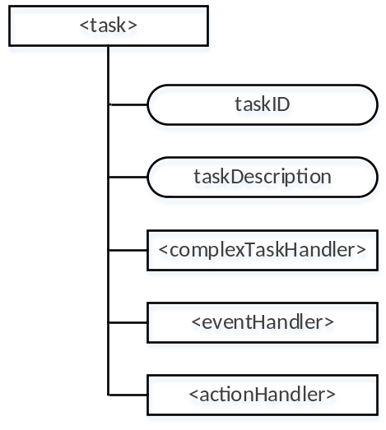

Figure 6.1-1: Resource model

The following clauses further analyse the mapping of these functional blocks to resource specifications.

6.2 Mapping of Action Handling
Several proposals for modelling of “actions” have been made for resources such as <operation>, <transaction>, etc. these proposals have the following in common with the concept of “action” in this context:
- A data flow using Input and Output resources (see Input Resource, Output Resource in clause 5.2, Input Parameters, Action Resource in clause 5.3 ),
- An action definition (see Action Detail, Action Type in clause 5.2, Figure 5.2-1 Operation in clause 5.3), specifying, for example: CRUDN operations, data flow direction,
However types of actions other than those modelled by <operation>/<transactions> require representation, e.g. internal timers, notifications, other internal logical operations, etc.

6.3 Mapping of Event Handling
Event handling requires specifying and monitoring events triggering the task to perform an action.
Currently the <eventConfig> resource provides means for specifying certain trigger types, filters and conditions.
- eventType (type of the event, such as timer based, data operation, storage based, etc.)
- eventStart ( start time of the event)
- eventEnd ( end time of the event)
- dataSize (stored data exceeds a certain size)
Other <eventConfig> attributes such as operationType are currently specialized for charging events.

Based on in clause 5.2 (Subject Resource, Filter condition, Dependent conditions) and in clause 5.3 (Trigger Information) additional attributes are needed to fully specify event handling. These attributes include additional trigger conditions, priorities
This can be accomplished either by enhancements to the <eventConfig> resource type, or by defining a new resource type.

6.4 Mapping of Complex Task Handling
Complex Task Handling requires identifying tasks as either individual or complex, and using task descriptions, including possible logical relationships between tasks to provide overall task management.
Currently no resource types include attributes designed for specifying such information. Attributes necessary include those expressing: IDs of individual tasks related, the logical relation between individual tasks, etc.

7 Potential solution in oneM2M
The following text is to be used when appropriate:

7.1 New Task Management Common Service Function
Action triggering is one of the major benefit that a service platform can provide. It can be regarded as a common service funtion that is provided by the service platform. Applications can utilize this function to outsource business logic to the platform, rather than withholding the business logic through frequent message transfers, applications can safely go to sleep or roam away after the deployment of the task to the service platform.
It is proposed to define a new Task Management Common Service Funtion (TM CSF) to the CSE apart from the current existing CSFs. The TM CSF is to manage the lifecycle of the actions defined in the CSE including the creation, update, operation, retrieve and delete of the actions. There could be multiple actions managed by the TM CSF, the actions could be logically related or independent. They could have an explicit sequence of operation according to time or parallel. The TM CSF is in charge of the enforcement of these actions.

7.2 New resource types

7.2.1 Action resource type
An <action> resource represents information about an action that is to be operated on a certain resource depending on certain conditions.
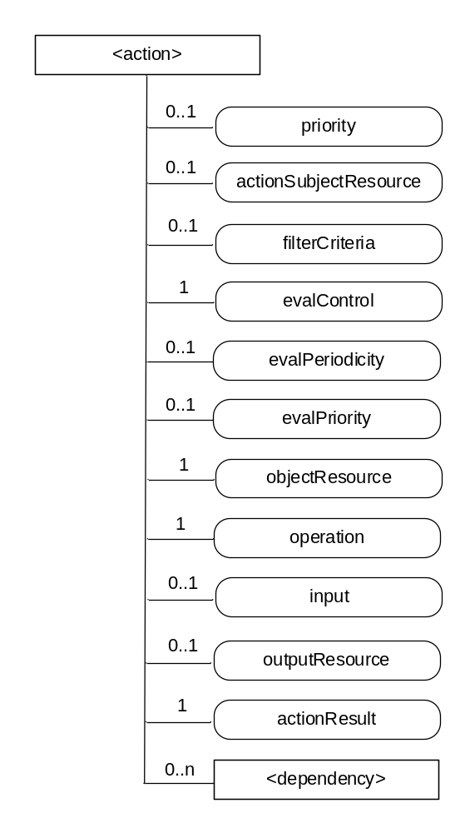
Figure 7.2.1-1: Structure of <action> resource
The <action> resource contains the child resources specified in table 7.2.1-1.
Table 7.2.1-1: Child resources of <action> resource
Child Resources of <action> | Child Resource Type | Multiplicity | Description | <actionAnnc> Child Resource Types
[variable] | <dependency> | 0..n | See clause 7.2.2 | <dependencyAnnc>
The <action> resource contains the attributes specified in table 7.2.1-2.
Table 7.2.1-2: Attribute of <action> resource
Attributes of  <action> | Multiplicity | RW/  RO/  WO | Description | <actionAnnc> Attributes
actionSubjectResource | 0..1 | RW | The resource that is the subject for triggering the evaluation of the filterCriteria attribute. The subject can be any resource in the system. If the attribute is missing the subject is the parent resource. | OA
priority | 0..1 | RW | The attribute indicates the priority of the action when compared with the other actions with the same actionSubjectResource, with highest priority indicated by the lowest value. | OA
filterCriteria | 0,,1 | RW | The filterCriteria to decide if the action is going to be triggered.. | OA
evalMode | 1 | RW | Attribute provides the macro control mode of the evaluation of the <action> resource. Some values are:  0 = off  1 = once  2 = periodic  3 = continuous | OA
evalControlParam | 0..1 | RW | When evalMode= periodic, evalControlParam represents the periodicity.  When evalMode= continuous the evaluation is restarted as soon as an action has been triggered. In this case, if evalControlParam is specified, it indicates the number of times to repeat an evaluation in continuous mode, otherwise it is repeated indefinitely.  When evalMode is off or once this attribute can be ignored. | OA
evalPriority | 0..1 | RW | Prioritized list of the dependencies for evaluation. This is an ordered list of The resourceIDs of the child <dependency> resources. | OA
objectResource | 1 | RW | The object resource that the operation is going to operate on. The resource could be any of the resource in the system. | MA
operation | 1 | RW | The operation that is going to be performed. The operation could be Create, Update, Retrieve, Delete or Notify. | MA
input | 0..1 | RW | Input parameter for the operation. The attribute could be the value of the input parameter or could be the reference to the resource which is the input. | OA
outputResource | 0..1 | RO | The reference to the resource where the result of the action can be retrieved. | OA
actionResult | 1 | RO | The result of the action. If outputResource is set, the actionResult is the retrieved resource representation of the outputResource. Otherwise, it’s the result of the request. | OA

7.2.2 Dependency resource type
An <dependency> resource represents the condition that determines if the related parent <action> resource can be operated.
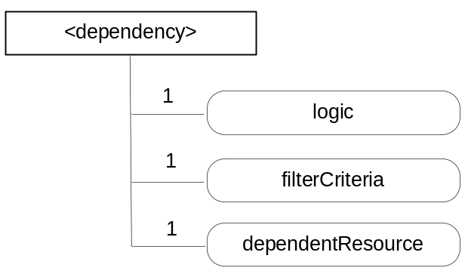
Figure 7.2.2-1: Structure of <dependency> resource
The <dependency> resource contains the attributes specified in table 7.2.2-1.
Table 7.2.2-1: Attribute of <dependency> resource
Attributes of  <dependency> | Multiplicity | RW/  RO/  WO | Description | <dependencyAnnc> Attributes
logic | 0..1 | RW | Indicates if the dependency is SUFFICIENT or NECESSARY. The operand of the related parent <action> resource needs to match:  Either of the sufficient dependency OR  All of the necessary dependency | OA
filterCriteria | 0,,1 | RW | The filterCriteria to decide if the dependency matches the criteria. | OA
dependentResource | 1 | RW | The resourceID of the resource that the filterCriteria applies on. | MA

7.2.3 Action triggering Procedure
The Hosting CSE of the <action> resource follows the steps below to perform an action triggering.
Step 1: <action> resource is created either as the child resource of subject resource or elsewhere in the resource tree.. The subject resource can be any of the resources defined in oneM2M, and is indicated by the actionSubjectResource attribute. A change on the subject resource triggers the evaluation of the filterCriteria. The <dependency> resources are created as the child resources of the <action> resource.
Step 2: Subject resource is updated.
Step 3: Check if the updated subject resource matches the criteria defined in the filterCriteria attribute in the <action> resource.
Step 4: Upon successful check in step 3, retrieve <dependency> child resources in the order provided in the evalPriority attribute, or based on local policy if the attribute is missing. For each of the <dependency> child resource, retrieve dependent resource according to the dependentResource attribute.If the dependent resource matches the criteria defined in the filterCriteria attribute and the logic attribute is of value SUFFICIENT, go to step 5. Otherwise if the dependent resource matches the criteria defined in the filterCriteria attribute and the logic attribute is of value NECESSARY, the hosting CSE checks if all the other <dependency> child resources which have the logic attribute of value NECESSARY match their filterCriteria attribute. If so, go to step 5.
Step 5: Retrieve the input resource if the input attribute of the <action> resource is a resource reference.
Step 6: Compose the operation depending on the operation attribute of the <action> resource and the retrieved input from step 5.
Step 7: Send the composed operation to the object resource according to the resourceID obtained from the objectResource attribute of the <action> resource.
Step 8: After receiving the response of the request in step 7, if outputResource attribute of the <action> resource is set, retrieve the resource representation of the outputResource and set the representation as the actionResult. Otherwise, put the state of the response in the actionResult attribute.

Proforma copyright release text block
This text box shall immediately follow after the heading of an element (i.e. clause or annex) containing a proforma or template which is intended to be copied by the user. Such an element shall always start on a new page.
Notwithstanding the provisions of the copyright clause related to the text of the present document, oneM2M grants that users of the present document may freely reproduce the <proformatype> proforma in this {clause|annex} so that it can be used for its intended purposes and may further publish the completed <proformatype>.
<PAGE BREAK>

Annexes
Each annex shall start on a new page (insert a page break between annexes A and B, annexes B and C, etc.).
Use the Heading 9 style for the title and the Normal style for the text.
Annex <A>:
Title of annex (style H9)
<Text>
<PAGE BREAK>
Annex <B>:
Title of annex (style H9)
<Text>
B.1 First clause of the annex (style H1)
<Text>
B.1.1 First subdivided clause of the annex (style H2)
<Text>
<PAGE BREAK>

Annex <y>:
Bibliography
The annex entitled "Bibliography" is optional.
It shall contain a list of standards, books, articles, or other sources on a particular subject which are not mentioned in the document itself.
It shall not include references mentioned in the document.
Use the Heading 9 style for the title and B1+ or Normal for the text.
- <Publication>: "<Title>".
OR
<Publication>: "<Title>".
<PAGE BREAK>

History
This clause shall be the last one in the document and list the main phases (all additional information will be removed at the publication stage).
Publication history
V.1.1.1 | <dd Mmm yyyy> | <Milestone>

Draft history (to be removed on publication)
V.0.0.1 | 21 July 2015 | Initial skeleton
V.0.1.0 | 10 October 2015 | Incorporated contributions:  ARC-2015-2095R01-TR-0021_Objective_and_values  ARC-2015-2096R02-TR-0021_Referencing_schema  ARC-2015-2097R02-TR-0021_Major_composition
V.0.2.0 | 16 November 2015 | Incorporated contribution:  ARC-2015-2231R01-Proposal_for_section_5_3_of_TR-0021_Another-Approach-for-Action-Trigge
V.0.3.0 | 2 February 2016 | Incorporated contribution:  ARC-2016-0061-TR-0021_analysis_clause_additions
V.0.4.0 | 30 May 2016 | Incorporated contribution:  ARC-2016-0271-TR0021_potential_solution_in_oneM2M  Some editorials.
V.0.5.0 | 28 July 2016 | Incorporated contribution:  ARC-2016-0332R02-TR-0021_resource_use_sec_7

